**PAAVAI ENGINEERING COLLEGE**

**(An Autonomous Institution)**

**A NATIONAL LEVEL TECHNICAL SYMPOSIUM**

**TECHFINIX’24**

PROJECT EXPO

**Decentralized Voting Application**

**OBJECTIVE:**

* To develop a secure and transparent decentralized voting application leveraging blockchain technology.
* To eliminate reliance on centralized authorities and reduce the potential for vote manipulation.
* To enable a verifiable and tamper-proof voting process that enhances trust and transparency in election systems.

**ABSTRACT:**

* This Decentralized Voting Application employs Ethereum blockchain and smart contracts to allow secure, transparent, and immutable voting.
* By eliminating intermediaries, the system ensures that every vote is accurately recorded and publicly verifiable on the blockchain.
* The application's design supports various use cases, from corporate voting to public elections, offering a modern, secure solution to traditional voting systems.

**INNOVATION:**

* Implementation of a decentralized, blockchain-based voting platform using Ethereum for transparent and tamper-resistant records.
* Smart contracts automatically manage vote counting and result publishing, ensuring accuracy without manual intervention.
* Wallet-based voter authentication provides a robust verification method, allowing only eligible users to cast votes.

**TECHNOLOGY INVOLVED:**

* **Smart Contract Development:** Solidity for smart contract creation on the Ethereum blockchain.
* **Frontend Development:** ReactJS for creating an interactive and user-friendly voting interface.
* **Blockchain Network:** Ethereum for decentralized execution and storage of voting records.
* **Truffle Suite:** Development framework for smart contract testing and deployment.
* **MetaMask:** Wallet for user identity verification and transaction management.

**OUTCOMES:**

* Enhanced security and transparency in voting processes, with immutable records stored on the blockchain.
* Increased accessibility, allowing verified participants to vote from anywhere, ensuring privacy and anonymity.

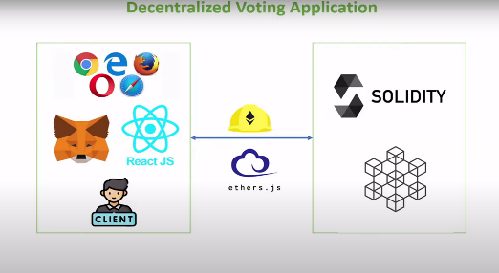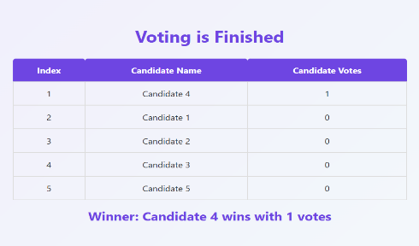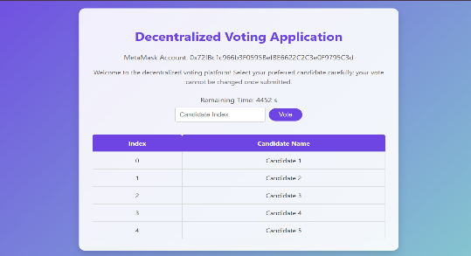**IMAGES:**

**Project By-**

**S. Sowmiyalakshmi, M.Pragathi , M.S. Sanjith -Third Year, IT**